SMTP Sampler:

Simple Mail Transfer Protocol , it is used to send a request to smtp server and server send email to destination and then server responses as success to jmeter.

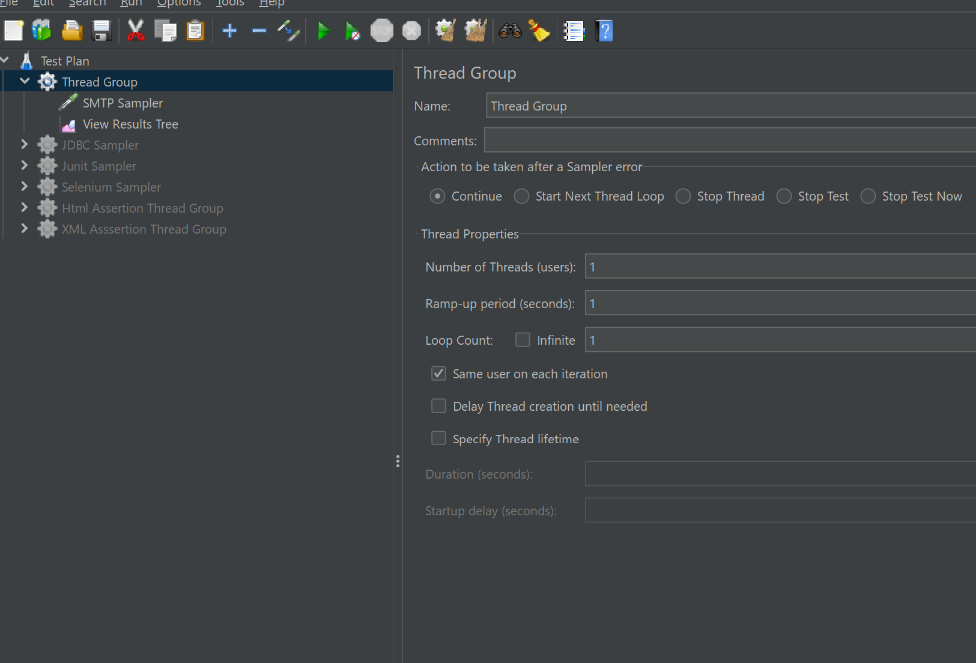

As below we need one side gmail credentials to send mail. Smtp sampler has message box to send a request to jmeter .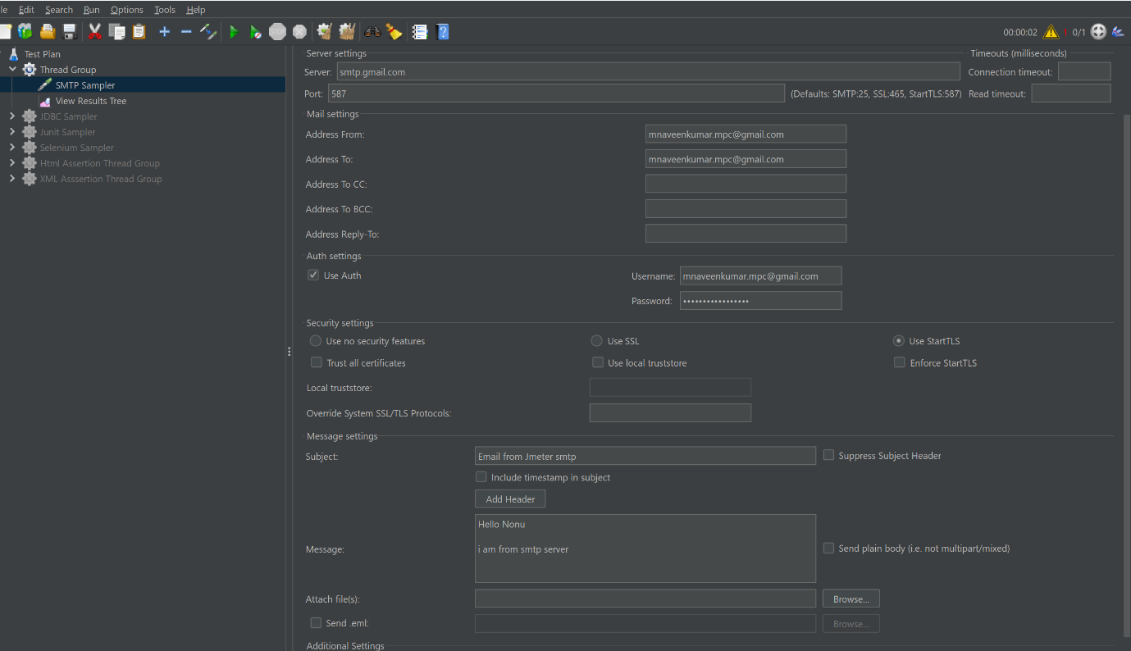

As a third party tool . gmail account doesn’t give valid credentials to jmeter to send message.

